
Department of Basic Engineering Science - 1
DATA STRUCTURES
I/IV-B.Tech-(II Sem), Academic Year: 2024-2025

Session-3.1(Tree and Tree Terminologies)
Instructional Objective:
- Demonstrate Tree Terminologies
- Describe the Binary Tree
- List out Types of Binary tree and Tree Traversal

Learning Outcomes:
- Define Tree and Its Terminologies
- Describe the Binary Tree and Its Traversal
- Summarized with examples.

Introduction:
The tree is a nonlinear hierarchical data structure and comprises a collection of entities known as nodes. It connects each node in the tree data structure using "edges”, both directed and undirected.
Other data structures like arrays, linked-list, stacks, and queues are linear data structures, and all these data structures store data in sequential order. Time complexity increases with increasing data size to perform operations like insertion and deletion on these linear data structures. But it is not acceptable for today's world of computation.The non-linear structure of trees enhances the data storing, data accessing, and manipulation processes by employing advanced control methods traversal through it.
Explanation:

Definition: A tree T is a set of nodes storing elements such that the nodes have a parent-child relationship.
Recursive Definition: T(tree) is either empty or consists of a node r (the root) and a possibly empty set of trees whose roots are the children of r.
Applications:
• Unlike Array and Linked List, which are linear data structures, tree is hierarchical (or non-linear) data structure.
• If we organize keys in form of a tree (with some ordering e.g., BST), we can search for a given key in moderate time (quicker than Linked List and slower than arrays).
• Like Linked Lists and unlike Arrays, Pointer implementation of trees do not have an upper limit on number of nodes as nodes are linked using pointers.
Node: It represents a termination point in a tree.
Root: A tree’s topmost node.
Parent: Each node (apart from the root) in a tree that has at least one sub-node of its own is called a parent node.
Child: A node that straightway came from a parent node when moving away from the root is the child node.
Leaf Node: These are external nodes. They are the nodes that have no child.
Internal Node: As the name suggests, these are inner nodes with at least one child.
SIBLINGS: The child nodes of same parent are said to be siblings. Siblings are always at the same level. All nodes at a particular level are said to be same generation

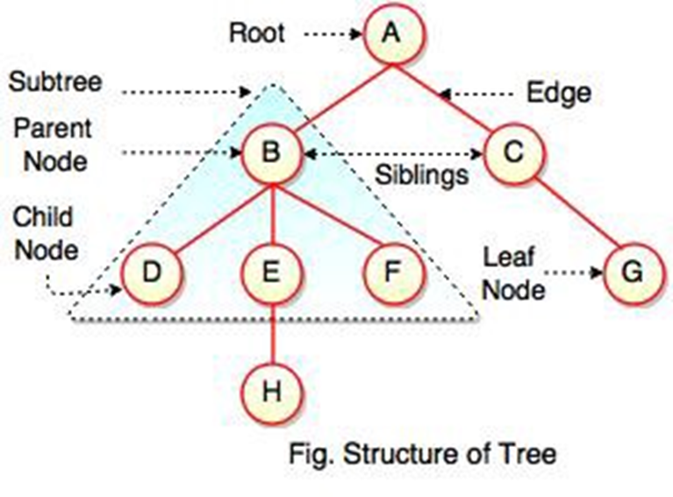

TREE TRAVERSAL

Traversal is a process to visit all the nodes of a tree and may print their values too. Because, all nodes are connected via edges (links) we always start from the root (head) node. That is, we cannot randomly access a node in a tree. There are three ways which we use to traverse a tree −
In-order Traversal
Pre-order Traversal
Post-order Traversal
Generally, we traverse a tree to search or locate a given item or key in the tree or to print all the values it contains.
In-order Traversal
In this traversal method, the left subtree is visited first, then the root and later the right sub-tree. We should always remember that every node may represent a subtree itself.
If a binary tree is traversed in-order, the output will produce sorted key values in an ascending order.
We start from A, and following in-order traversal, we move to its left subtree B. B is also traversed in-order. The process goes on until all the nodes are visited. The output of inorder traversal of this tree will be
D → B → E → A → F → C → G

Algorithm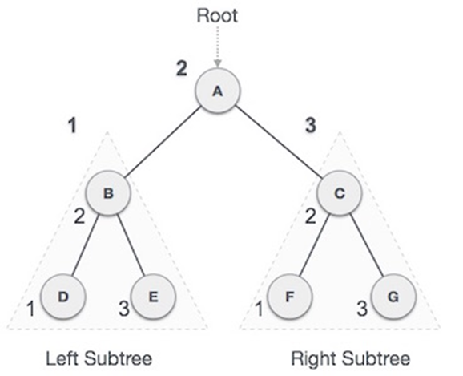
Until all nodes are traversed −
Step 1 − Recursively traverse left subtree.
Step 2 − Visit root node.
Step 3 − Recursively traverse right subtree

Pre-order Traversal
In this traversal method, the root node is visited first, then the left subtree and finally the right subtree.
We start from A, and following pre-order traversal, we first visit A itself and then move to its left subtree B. B is also traversed pre-order. The process goes on until all the nodes are visited. The output of pre-order traversal of this tree will be −
A → B → D → E → C → F → G

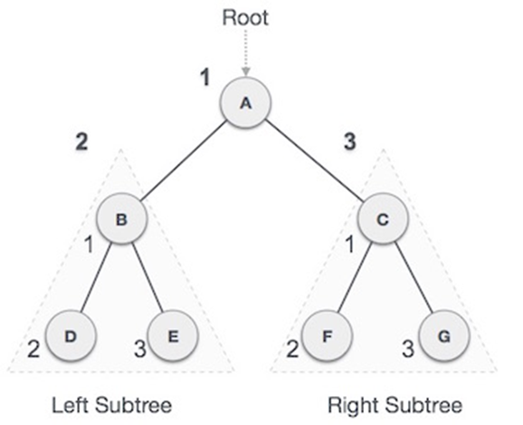
Algorithm
Until all nodes are traversed −
Step 1 − Visit root node.
Step 2 − Recursively traverse left subtree.
Step 3 − Recursively traverse right subtree

Post-order Traversal
In this traversal method, the root node is visited last, hence the name. First we traverse the left subtree, then the right subtree and finally the root node.
We start from A, and following Post-order traversal, we first visit the left subtree B. B is also traversed post-order. The process goes on until all the nodes are visited. The output of post-order traversal of this tree will be −

D → E → B → F → G → C → A

Algorithm
Until all nodes are traversed −
Step 1 − Recursively traverse left subtree.
Step 2 − Recursively traverse right subtree.
Step 3 − Visit root node

BINARY TREE

The Binary tree means that the node can have maximum two children. Here, binary name itself suggests that 'two'; therefore, each node can have either 0, 1 or 2 children.
Properties of Binary Tree :
1.At each level of i, the maximum number of nodes is 2i.
2.The height of the tree is defined as the longest path from the root node to the leaf node. The tree which is shown above has a height equal to 3. Therefore, the maximum number of nodes at height 3 is equal to (1+2+4+8) = 15. In general, the maximum number of nodes possible at height h is (20 + 21 + 22+….2h) = 2h+1 -1.
3.The minimum number of nodes possible at height h is equal to h+1.
4.If the number of nodes is minimum, then the height of the tree would be maximum. Conversely, if the number of nodes is maximum, then the height of the tree would be minimum.
5.If there are 'n' number of nodes in the binary tree.

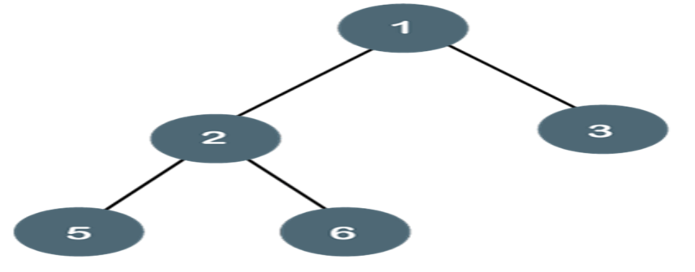

Types of Binary Tree :
There are four types of Binary tree:
Full/ proper/ strict Binary tree
Complete Binary tree
Perfect Binary tree
Degenerate Binary tree
Balanced Binary tree

Full binary tree
A tree in which every node has two children except the external node (leaves) is called a full binary tree.
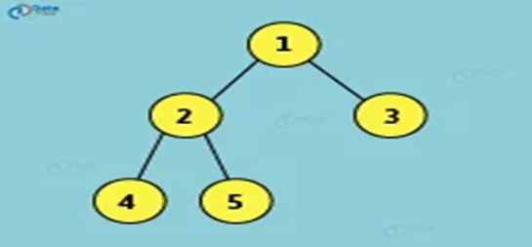

Complete binary tree
A tree in which every level except the last level is filled completely and all nodes are as far left as possible is called a complete binary tree

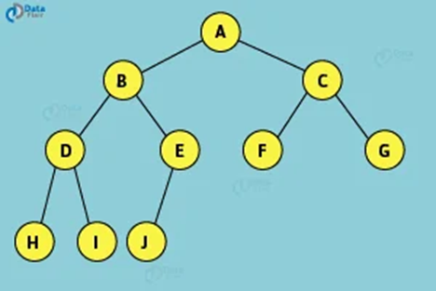

Expression trees
Expression trees are those in which the leaf nodes have the values to be operated, and internal nodes contain the operator on which the leaf node will be performed.
Example
4 + ((7 + 9) * 2) will have an expression tree as follows
Algorithm:
If T is not NULL:
If T->data is an operand:
return T.data
A = solve(T.left)
B = solve(T.right)
--> Calculate operator for 'T.data' on A and B, and call recursively,
return calculate(A, B, T.data)

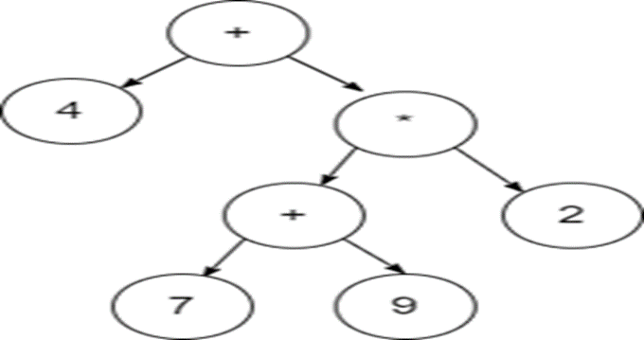

Example: 1
Construct an tree for expression a + (b * c) + d * (e + f)
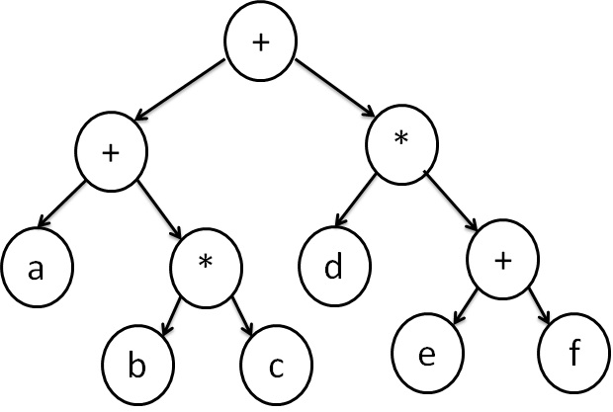

Review questions:
1. Describe Binary Tree and its Types with examples
2. List out the applications of Trees
3. Analyze How to construct a Expression Tree E=(A-B)/((C*D)+E)

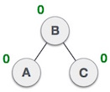
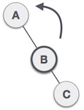
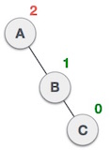
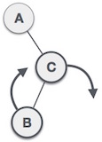
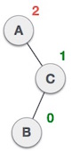
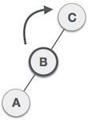
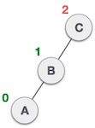
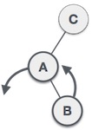
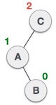
Summary:

- TREE TERMINOLOGIES,TREE TRAVERSAL

- BINARY TREE AND ITS TYPES ,EXPRESSION TREE

- EXAMPLES ON EXPRESSION TREE

Self-assessment questions:

- Which of the following is a true about Binary Trees
  - Every binary tree is either complete or full
  - Every complete binary tree is also a full binary tree
  - Every full binary tree is also a complete binary tree
  - No binary tree is both complete and full
  - None of the above
- If arity of operators is fixed, then which of the following notations can be used to parse expressions without parentheses? a) Infix Notation (Inorder traversal of a expression tree) b) Postfix Notation (Postorder traversal of a expression tree) c) Prefix Notation (Preorder traversal of a expression tree)
  - b and c
  - Only b
  - a, b and c
  - None of them
- Level of a node is distance from root to that node. For example, level of root is 1 and levels of left and right children of root is 2. The maximum number of nodes on level i of a binary tree is
  - 2^(i-1)
  - 2^
  - 2^(i+1)
  - 2^[(i+1)/2]
- In a complete k-ary tree, every internal node has exactly k children or no child. The number of leaves in such a tree with n internal nodes is:
  - Nk
  - (n – 1) k+ 1
  - n( k – 1) + 1
  - n(k – 1)
- The maximum number of binary trees that can be formed with three unlabelled nodes is:
  - 1
  - 5
  - 4
  - 3
- A complete n-ary tree is a tree in which each node has n children or no children. Let I be the number of internal nodes and L be the number of leaves in a complete n-ary tree. If L = 41, and I = 10, what is the value of n?
  - 6
  - 3
  - 4
  - 3
- The height of a binary tree is the maximum number of edges in any root to leaf path. The maximum number of nodes in a binary tree of height h is:
  - 2^h -1
  - 2^(h-1) – 1
  - 2^(h+1) -1
  - 2*(h+1)

Terminal questions
- Types of Representationof a Tree
- Contruct an Tree For an Expression 7 + ((1+8)*3)
Practice Problems

1 . Display the detailed contents of the stack to construct an expression tree for the given postfix expression G N H + * E A / RM + % -?
2. Draw the binary tree for the given in-order: T Q U V S P X Z Y R W and Post-order: T V U S Q Z Y X W R P.
3.Write an algorithm to construct an expression tree and trace it with the postfix expression L M A/+B C – D F / G E % + * Display the in-order and post-order traversal of the resultant expression tree?
4. Define the expression tree and show the detailed contents of the stack to construct an expression tree for the postfix expressions PQ-LK*+MN+/.?

